**MARINE RESOURCES**

**Bridge Bust (Nassau County)**

On October 2, 2016 ECOs Ian Helmer and Rob Howe were checking fishermen under the bridges on the Meadowbrook Parkway in the Town of Hempstead. Officer Howe had been watching one of the regular poaching spots from a distance earlier and saw several men catching fish. ECO Helmer and Howe approached the group and found one fisherman to be well over the legal limit of eight black sea bass. This individual had a total of 31 black sea bass and one porgy, all of which were under the legal size limit. The fisherman was issued summonses for the violations.

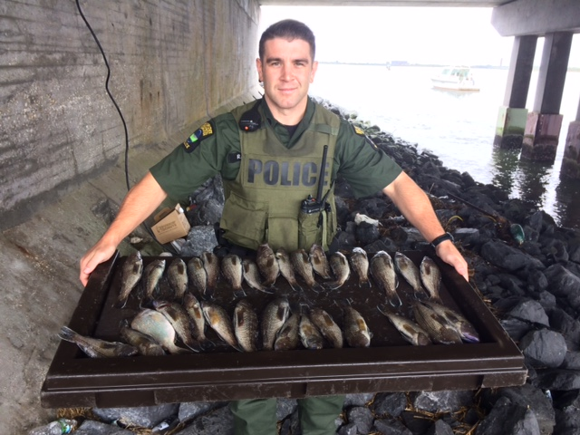

**Early Blackfish (Nassau County)**

Throughout the week prior to the tautog (blackfish) season opening of October 5, 2016 ECOs Ian Helmer, Rob Howe and Mike Unger responded to multiple complaints of people taking tautog out of season. The ECOs focused much of their attention to the popular Green Island Fishing Piers in Jones Beach State Park. Working as a team, one officer would watch the fishermen and identify who was taking blackfish out of season and relay the information to another officer, who would confront the individual. The ECOs caught multiple people with blackfish at Green Island on the three days prior to season opener, with multiple summonses issued.

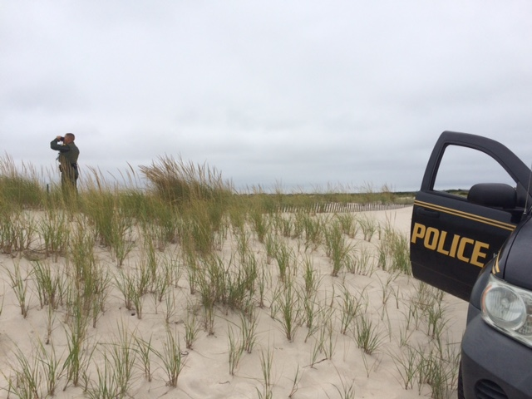

**Brush Up on Your Regs! (Suffolk County)**

On October 5, 2016 ECOs Jeremy Eastwood, Chris Amato, and Katie Jakaub were on patrol in East Hampton when they spotted three groups of fishermen packing up ready to leave from a popular charter boat. The groups had a few coolers each and agreed to let the ECOs inspect their day’s catches. Apparently the individuals failed to brush up on the new regulations regarding minimum length of Black Sea Bass and were going off of last year’s 13 inch size limit. Between groups a total of 14 Black Sea Bass were found along with one short Porgy. Each of the responsible parties were issued summonses for possessing undersized fish as well as updated copies of the new regulations.

**House Call (Suffolk County)**

On October 6, 2016 ECO Rob Howe was given a tip of a fisherman keeping undersize tautog and black sea bass. The officer was already on a separate complaint, and was just a few minutes too late to catch the poacher. Fortunately, the complainant got the fisherman’s license plate, which enabled ECO Howe to respond to the suspect’s home. The officer waited until the suspect arrived shortly thereafter. ECO Howe interviewed the man and asked him if he was fishing today, to which the man replied no. The officer then questioned the fact that he had fishing gear in his back seat, to which the man gave in and said he was fishing. He then voluntarily allowed Officer Howe to look for fish in the back seat of the car. The officer found three undersize blackfish and one undersize black sea bass, and issued tickets for the violations.

**One Last Boat Before Sunset (Suffolk County)**

On October 10, 2016 ECOs Jordan Doroski and Kevin Holzle were checking for vessels coming into Montauk Harbor when one last boat headed into the town ramp at sunset. There were four individuals on the boat and they were happy to say that they had a productive day of black sea bass fishing. ECO Holzle asked to check the fish and a found a storage seat full of porgy and black sea bass. Twenty of those sea bass were found to be under the legal requirement of fifteen inches and the two ECOs found another eight short sea bass in a live well. The captain of the vessel was issued a summons for the twenty eight undersize black sea bass and has a court date with East Hampton Town Court on December 7th.

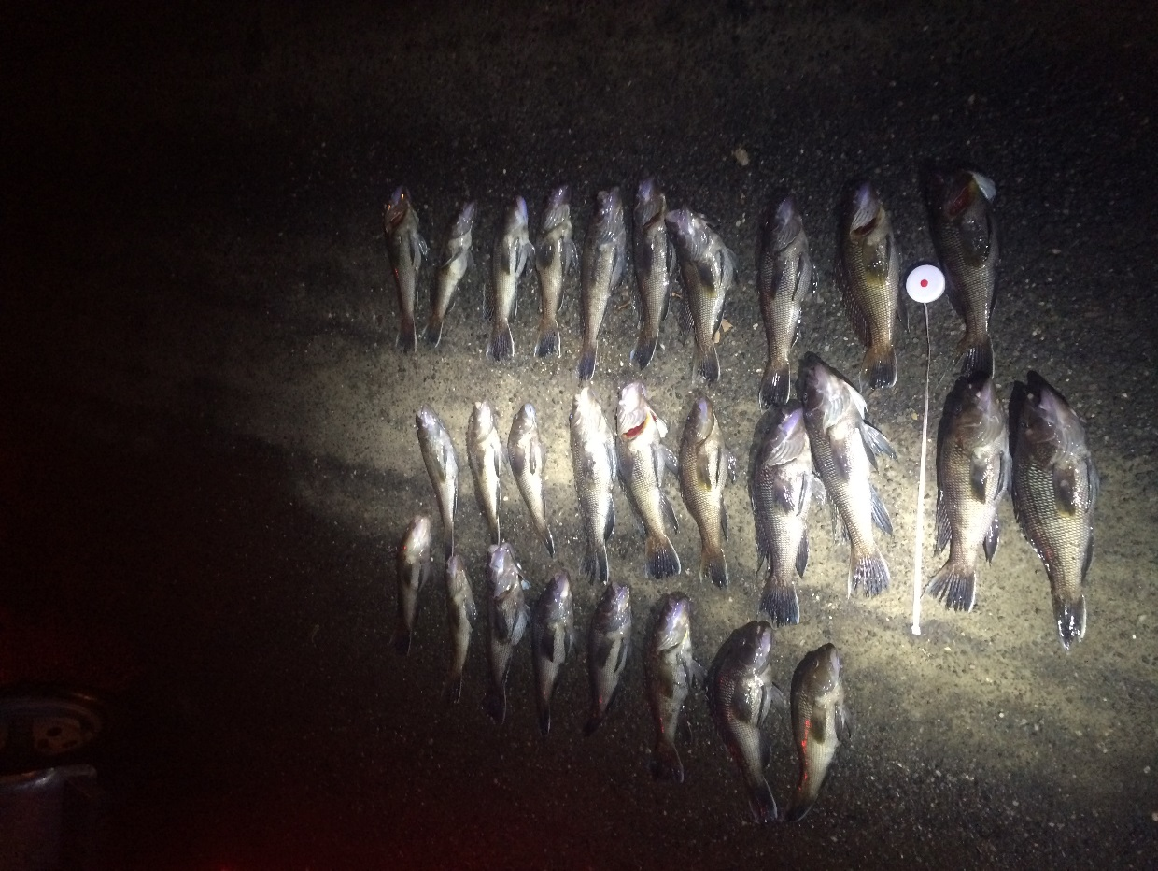

**Full Moon Striped Bass Detail (Nassau County)**

On October 15, 2016 ECOs Mike Unger, Emma Carpenter, Ian Helmer and Tim Brown conducted an overnight detail focused on striped bass fishing. They patrolled western Long Island Sound by boat and found a vessel without navigation lights. Further inspection revealed they also had no throw able PFD, but did have a small striped bass. Two of the occupants also failed to carry their marine registry. Tickets were issued for all the violations noted. Boating activity was slow so they moved to shore checks which were very productive. ECO Carpenter issued four tickets for undersized striped bass and one for over limit. By 6:00am on October 16th, the officers had seized 18 fish and issued a total of14 tickets.

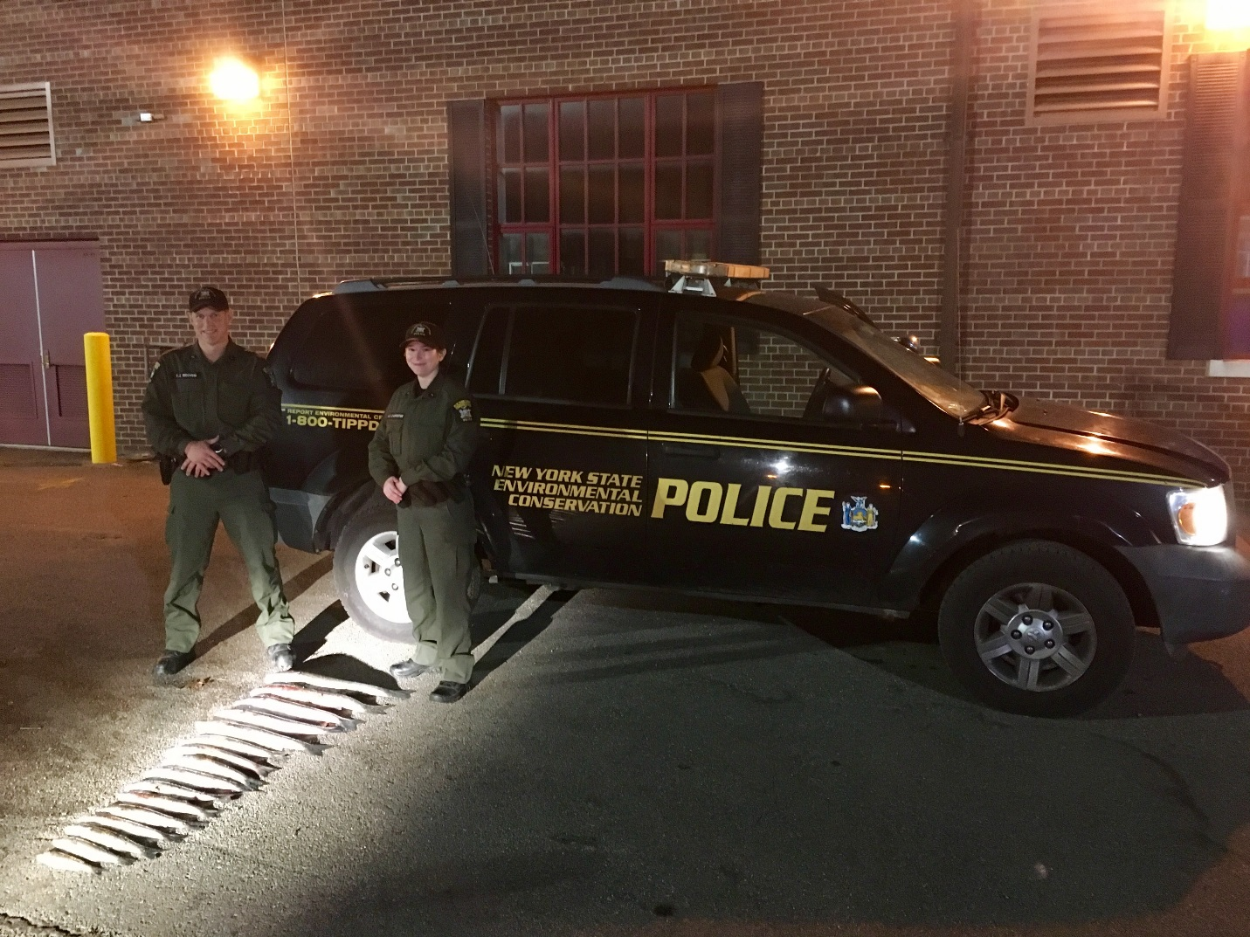

ECOs Brown and Carpenter with the seized striped bass.

**Naughty Neighbor (Nassau County)**

On October 17, 2016 ECOs Mike Unger and Emma Carpenter were returning from boat patrol on the Long Island Sound when they noticed a net hanging off the side of a boat a few slips down from where the patrol boat is docked. Upon investigation, the officers found four 4 live blackfish in the net. All the fish were shorter than the required 16 inches. The boat owner was interviewed, and he admitted that the fish were his. He was issued a summons for possessing short blackfish.

**Two is one too many (Nassau County)**

On the evening of October 22, 2016 ECO's Tim Brown and Ian Helmer observed a fisherman carrying a large black bag and fishing gear, heading towards his car. Upon a brief investigation, the officers discovered the man had two striped bass, with one measuring 21 inches. The fisherman also failed to possess a marine registry. Officer Brown issued three tickets, failure to carry a marine registry, over the limit for striped bass and undersized striped bass. The 21 inch striped bass was still alive and so was returned to the waters of NY.

**Same stuff, Different day (Nassau County)**

ECO Denise Ferraro patrolled to check fishermen during the early morning hours of October 23, 2016. The officer had just received information from one of her "regulars" that two men with buckets and a net were just dropped off by taxi. The pair cut through the brush and headed to the beach. ECO Ferraro responded to the area and watched the duo pull in the net and dump its contents in the bucket. After the Officer performed a compliance check, she issued summonses for violations including, possessing undersized fluke and crabs, out of season fluke, using an oversized net, and no marine fishing registry.

**Too Bad, So Shad (Suffolk County)**

On October 27, 2016 ECOs Nathan Godson and Ron Gross patrolled to Captree State Park North Pier to conduct marine fishing checks. Upon arrival, the ECOs observed two fishermen catching Hickory Shad. The officers began to approach the men when one of them reached for the bucket filled with fish. Both Officers signaled for the fisherman to stop dumping, but to no avail, as the man dumped out the fish. Despite dumping the contents of the bucket, the fishermen were found to be in possession of over the limit of Hickory Shad. The ECOs interviewed the subjects which led to a search of their vehicle, where another 23 shad were found, totaling 44 Hickory Shad. ECOs Godson and Gross seized the Hickory Shad and issued two citations for possessing over the limit and one written warning for dumping upon signal to stop.

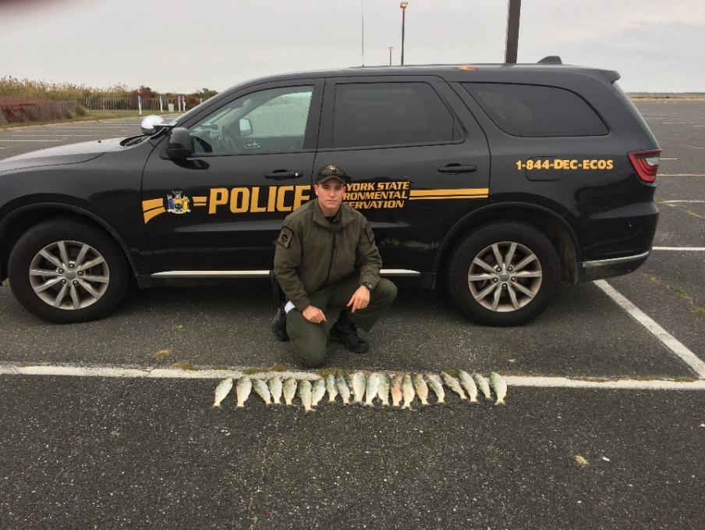

**Lieutenant Reels in a Violation – Queens County**

On October 17, 2016 ECOs Bradley Buffa, Jarrod Lamozik, Chris Macropolis, Lucas Palmeteer, Jeff Krueger, Jason Hilliard and Lt. Dawn Galvin were on boat patrol near Breezy Point, Queens County. Coming upon the charter boat Marilyn Jean IV in the Rockaway Inlet, the ECOs approached for boarding. As they did so two blue bags were thrown off the stern of the vessel. As the ECOs were inspecting the vessel, Marine Unit Lieutenant Galvin was able to quickly retrieve one of the bags prior to it sinking. It was found to contain an undersized tautog. After the ECOs matched the discarded bag to a fisherman on board that had identical bags in his cooler, he admitted to throwing the bag overboard. The fisherman was charged with possession of undersize tautog and dumping upon signal to stop. In addition to the tautog, an abandoned cooler was found on board that contained nine undersize black sea bass and an undersized scup. Numerous fisherman on board assisted the ECOs and identified the owner of the cooler who was issued summonses for the undersize fish after he admitted ownership.

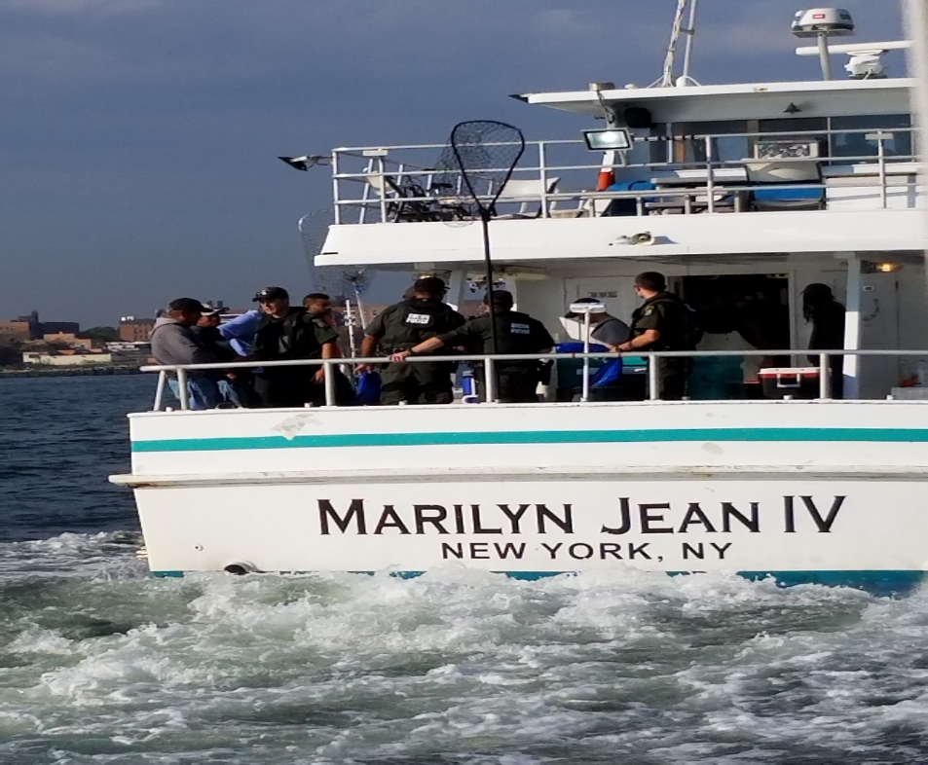

*ECO's aboard the Marilyn Jean conducting inspections.*

**The Bass Come Out At Night (Queens County)**

On October 15, 2016 while off duty, ECO Jeffery Krueger received a complaint regarding recreational fishermen taking undersize striped bass in Little Neck Bay in Queens. ECO Krueger contacted the regional designated coverage officers ECO Chris Macropoulos, ECO Zach Brown, and ECO Brad Buffa to respond to the anonymous complaint. The ECO’s arrived at the location at approximately 2030 hours and began checking recreational fishermen. Despite the fisherman’s fabricated stories on who caught what, ECO’s Macropoulos, Brown, and Buffa exposed the truth and issued 6 summons and 1 warning and seized over 20 undersized striped bass. A large portion of the fish were still alive and were returned to the waters of the state. The rest were properly disposed of.

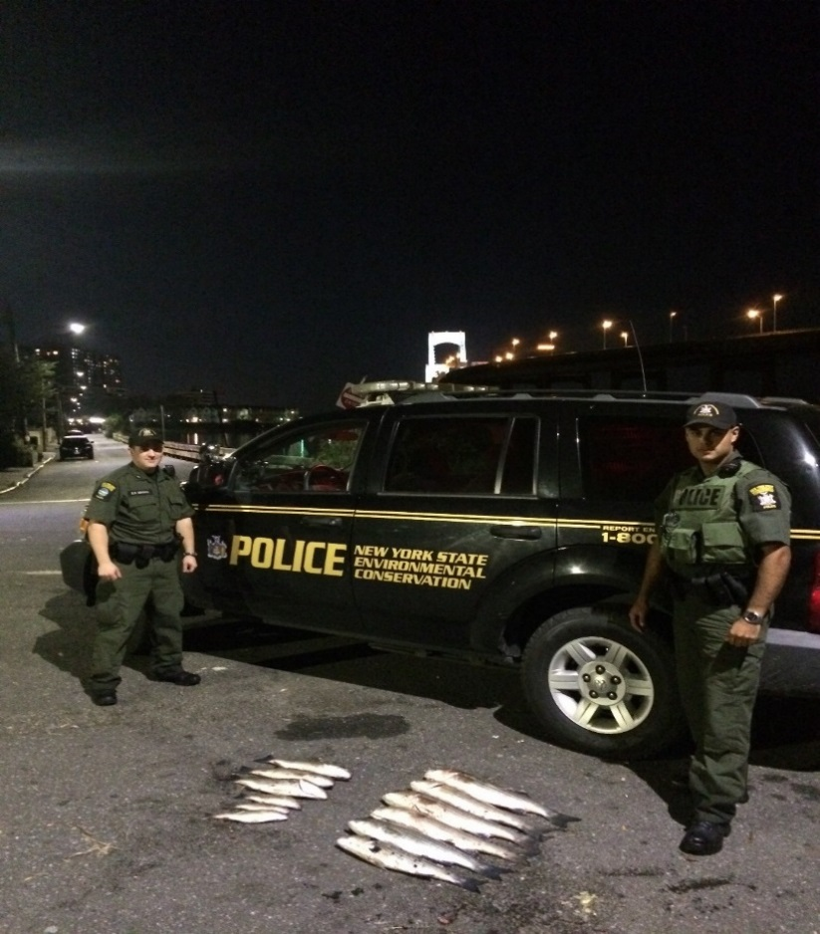

**36 Pounds of Blackfish and Porgy Seized in Chinatown (New York County)**

On October 19, 2016 ECO’s Noyes, Leubner, Johnson and Lt. Buckley set out into Chinatown for market inspections. One market turned out possessing a total of 36 pounds of illegal blackfish (tautog) and porgy (scup). Upon initial inspection, ECO’s Noyes and Johnson noticed several undersized porgy on display for sale. Further questioning led them back into a large walk-in freezer where two large crates of porgy were being kept, dozens being undersized. Lt. Buckley and ECO Leubner found several undersized blackfish in a large live-well tank. In total, 16 blackfish and 28 porgy were seized. The market was issued two criminal summons for Possession of Undersized Blackfish and Possession of Undersized Porgy. All 36 pounds of fish were donated to the Bowery Mission to help feed the homeless in New York City.

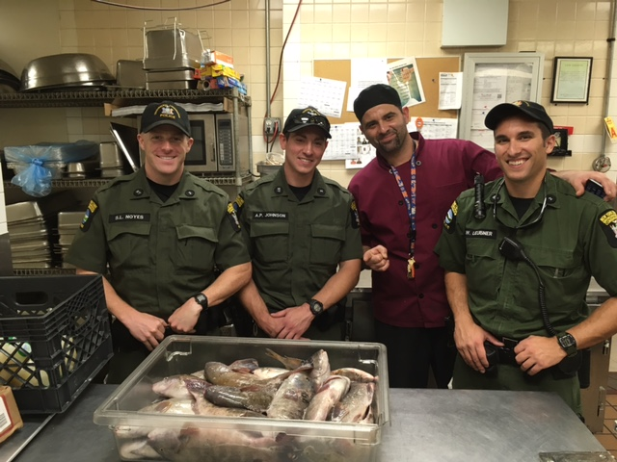

*From L to R, ECO’s Noyes, Johnson and Leubner donate seized fish to the delight of the Bowery Mission chef.*

**Party’s Over! – Queens County**

On October 12, 2016, ECOs Palmateer, Hameline and Walraven were on boat patrol on Rockaway Reef performing fishing checks on recreational fishing vessels. The officers boarded a party charter boat to ensure that all anglers were abiding by New York State fishing regulations. The majority of people aboard the vessel were playing by the rules, but three separate male subjects were found in possession of undersized fish; the first with thirteen undersized scup, the second with one undersized blackfish and the third with four undersized blackfish. The undersized scup were still alive and released back to the waters of the State. The blackfish were seized as evidence. After being interviewed, all three subjects admitted to taking undersized fish found in their possession. The ECOs issued three summonses; one for the possession of undersized scup and two for the possession of undersized blackfish.

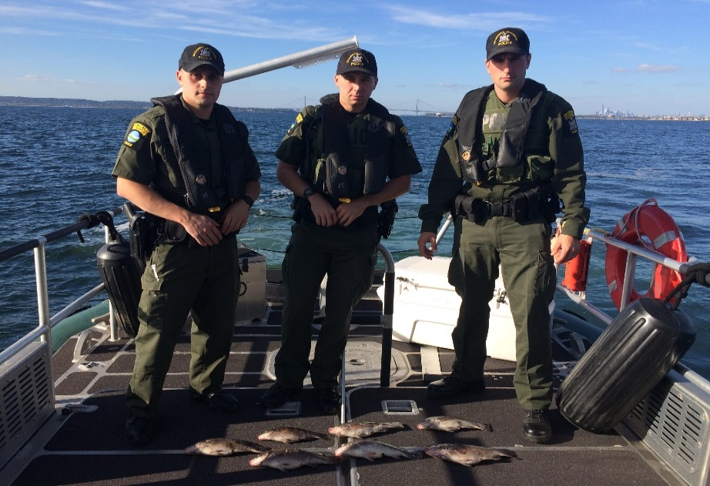

**Shellfish Seizure (Queens County)**

On Monday, October 24, 2016, ECOs Krueger and Palmateer were performing surveillance on H and Y Market in Queens, looking for an individual known to have been transporting undersized Atlantic Cod. ECO Krueger kept an eye on the parking lot while ECO Palmateer was staged around the corner in a marked patrol unit. When the subject matching the description entered the parking lot, ECO Palmateer followed in behind him and began questioning him. At this time, ECOs Auguscinski, Hameline and Macropoulos arrived on scene to assist. A search of the individual’s van produced multiple boxes of various food fish and several bags of assorted shellfish. Further questioning of the individual revealed that he did not have the proper permits to be transporting any of it. The individual was issued summonses for Failure to Possess a Food Fish Shipper/Dealer Permit and failure to possess a Shellfish Shipper Permit. The ECOs seized 30 2lb bags of Blue Cultured Mussels, 40 2lb bags of North Eastern Wild Mussels, 100 Oysters and 150 Cherrystone Clams.

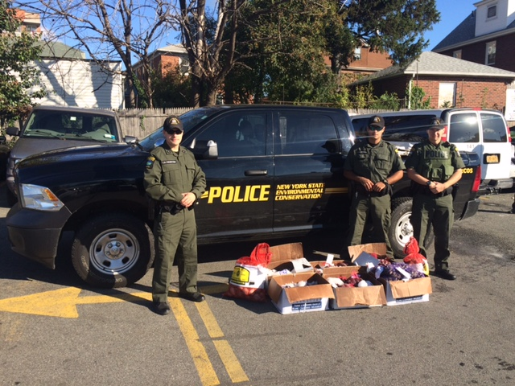

*ECOs Palmateer, Macropoulos and Hameline with seized shellfish.*

**ECO Nicols with illegally taken buck.**

**Fishing Enforcement (Westchester County)**

On October 24, 2016, ECO’s Geoffery Younglove, Tony Drahms, Zachary Crain and Peter Jackson conducted a marine patrol of the Long Island Sound. Utilizing the Department’s 24 foot Justice Boston Whaler, the ECOs conducted numerous safety and fishing inspections on various vessels including recreation boats and charter fishing vessels. During the patrol, the ECOs documented numerous violations of the Environmental Conservation Law, including the possession of undersized blackfish. Four Blackfish were found on one vessel averaging 12 inches each, well under the legal limit of 16 inches. The ECOs confiscated the fish and issued summonses to the responsible parties.

**Short Fish and a Save (Westchester County)**

ECOs Sulkey, Younglove, Tompkins and Drahms took advantage of the warm fall day on October 16, 2016 and went on a boat patrol in the Long Island Sound near the cities of Rye and New Rochelle. The officers checked well over a dozen vessels and found violations on most of them. At the end of the day, they issued nine tickets for the possession of undersized fish and seized 32 short fish, including five undersized blackfish and 27 undersized porgy. On the way back to dock, they encountered what they thought was another fishing boat. When they approached the vessel, the captain made several gestures down towards the engine. The small boat had lost most of the power in its engine and was stalling out. The ECOs instructed the four individuals inside to don their life jackets as they were being pushed towards the rocks near the Scotch Caps. The ECOs then escorted the slow-moving vessel and guided it back to launch near Mamaroneck.

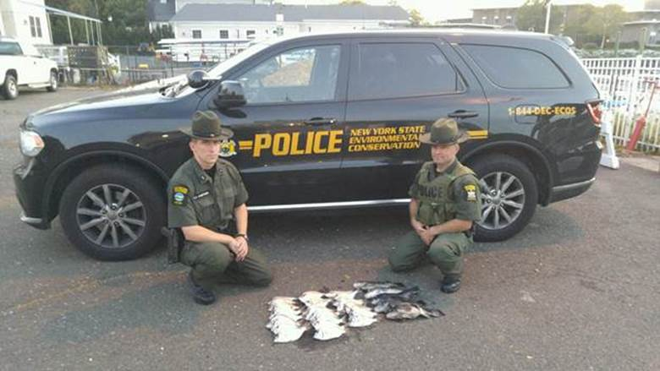

***ECO’s with seized undersized Blackfish and Porgy***