Will elevated CO₂ and temperature disrupt chemically mediated tri-trophic interactions? A case from a specialized Neotropical plant-herbivorous insect system

Fredric V. Vencl^{1, 2, 6}, Stefan Bartram⁴, Kerstin Ploss⁴, Klaus Winter³, Wilhelm Boland⁴ & Robert B. Srygley^{3, 5}
¹ Ecology and Evolution, Stony Brook University, Stony Brook, NY 11794-5245, USA
²National Museum of Natural History, Smithsonian Institution, Washington, DC, USA
³The Smithsonian Tropical Research Institute, Apdo. 0843-03092, Balboa, Ancón, Republic of Panamá
⁴Max-Planck-Institut für Chemische Ökologie, Hans-Knöll-Str. 8, 07745, Jena, Germany
⁵USDA-Agricultural Research Service, Northern Plains Agricultural Research Lab, 1500 N. Central Ave., Sidney, MT 59270, USA

Among the factors altering Earth's climate, rapid increases in temperature and atmospheric carbon dioxide are suspected to be the chief drivers of change that will continue to impact the performance, abundance, and distributions of plant and animal species (Berggren et al., 2009). The current atmospheric concentration of CO₂ of 400 μmol mol⁻¹ is forecast to rise to a forecast level of 540–970 μmol mol⁻¹ by the year 2100 (Houghton et al., 2001; Peters et al., 2012; IPCC, 2014).

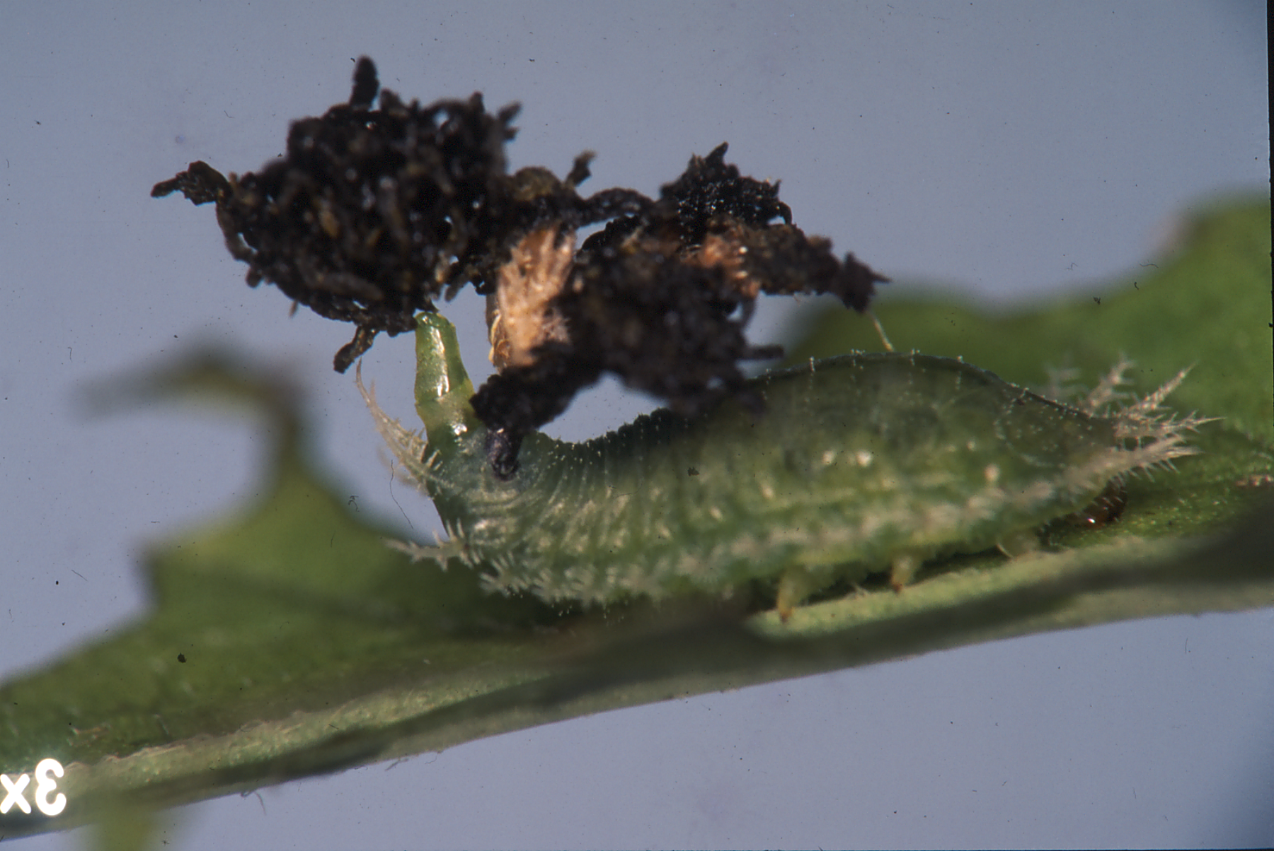
Little is known about how organisms involved in chemically mediated, multi-trophic interactions will respond to forecast elevated CO₂ and increased temperatures and whether tropical systems are more vulnerable to such increases. We investigated the diet specialized leaf beetle, Acromis sparsa (Chrysomelidae:Cassidinae), which feeds exclusively on the vine, Merremia umbellata (Convolvulaceae), and whose larvae sequester C-based and N-based host metabolites to fortify anti-predator shield defenses that are essential for survival. As a widespread native, M. umbellata colonizes forest edges, gaps, watercourses, and roadsides throughout the Neotropics and has become invasive throughout the humid tropics. Due to rapid forest fragmentation, M. umbellata resides in the fastest growing terrestrial habitat: the tropical forest edge ecotone (Haddid et al. 2015; Peralta et al., 2016). Despite their prevalence and ecological importance, forbs and herbaceous vines, such as M. umbellata, and the community that they harbor are poorly represented in our understanding of the effects of climate change.

Fig. 2. Larval tortoise beetle an parasol-like shield (circled) and telescoping anus applying host-derived anti-predator defensive chemicals to the shield (arrow).

Two of the most important hypotheses central to plant defense theory, the carbon-nutrient balance hypothesis (hereafter, CNBH; Bryant et al., 1983), and the growth-differentiation balance hypothesis (hereafter, GDBH; Herms & Mattson, 1992), make predictions about the potential of forecast changes in climate to alter levels of plant secondary metabolites used to thwart herbivores. The CNBH posits that excess carbon or nutrients above levels required for growth can be shunted into increased carbon- or nitrogen-based anti-herbivore defenses. Alternatively, the GDBH posits that plants synthesizing mainly carbon-based secondary metabolites should increase their production when fixed carbon exceeds requirements for growth ("carbon fertilization"). More generally, the GDBH predicts that abiotic variables that restrict growth before photosynthesis (e.g., CO₂, nutrients, water, temperature) will foster increased production of plant defenses by allocating excess carbon or nitrogen not required for growth.

In addition to resource availability, plant growth rate can influence resource allocation and defense levels. Bryant et al. (1983) hypothesized that fast-growing tropical plants colonizing ephemeral light gaps will invest more resources to attain rapid growth than in anti-herbivore chemical defenses, while their light-starved understory counterparts allocate more N to toxic chemicals to defend their slow-growing leaves. Accordingly, young, rapidly expanding leaves are better fodder for herbivores because they have not yet developed toughness as a defense and they contain more N.

But how well will the resource allocation CNBH, GDBH, or the growth rate hypothesis predict responses in a chemically-mediated, multi-trophic interaction under the influence of forecast increases in temperature and [CO₂]?
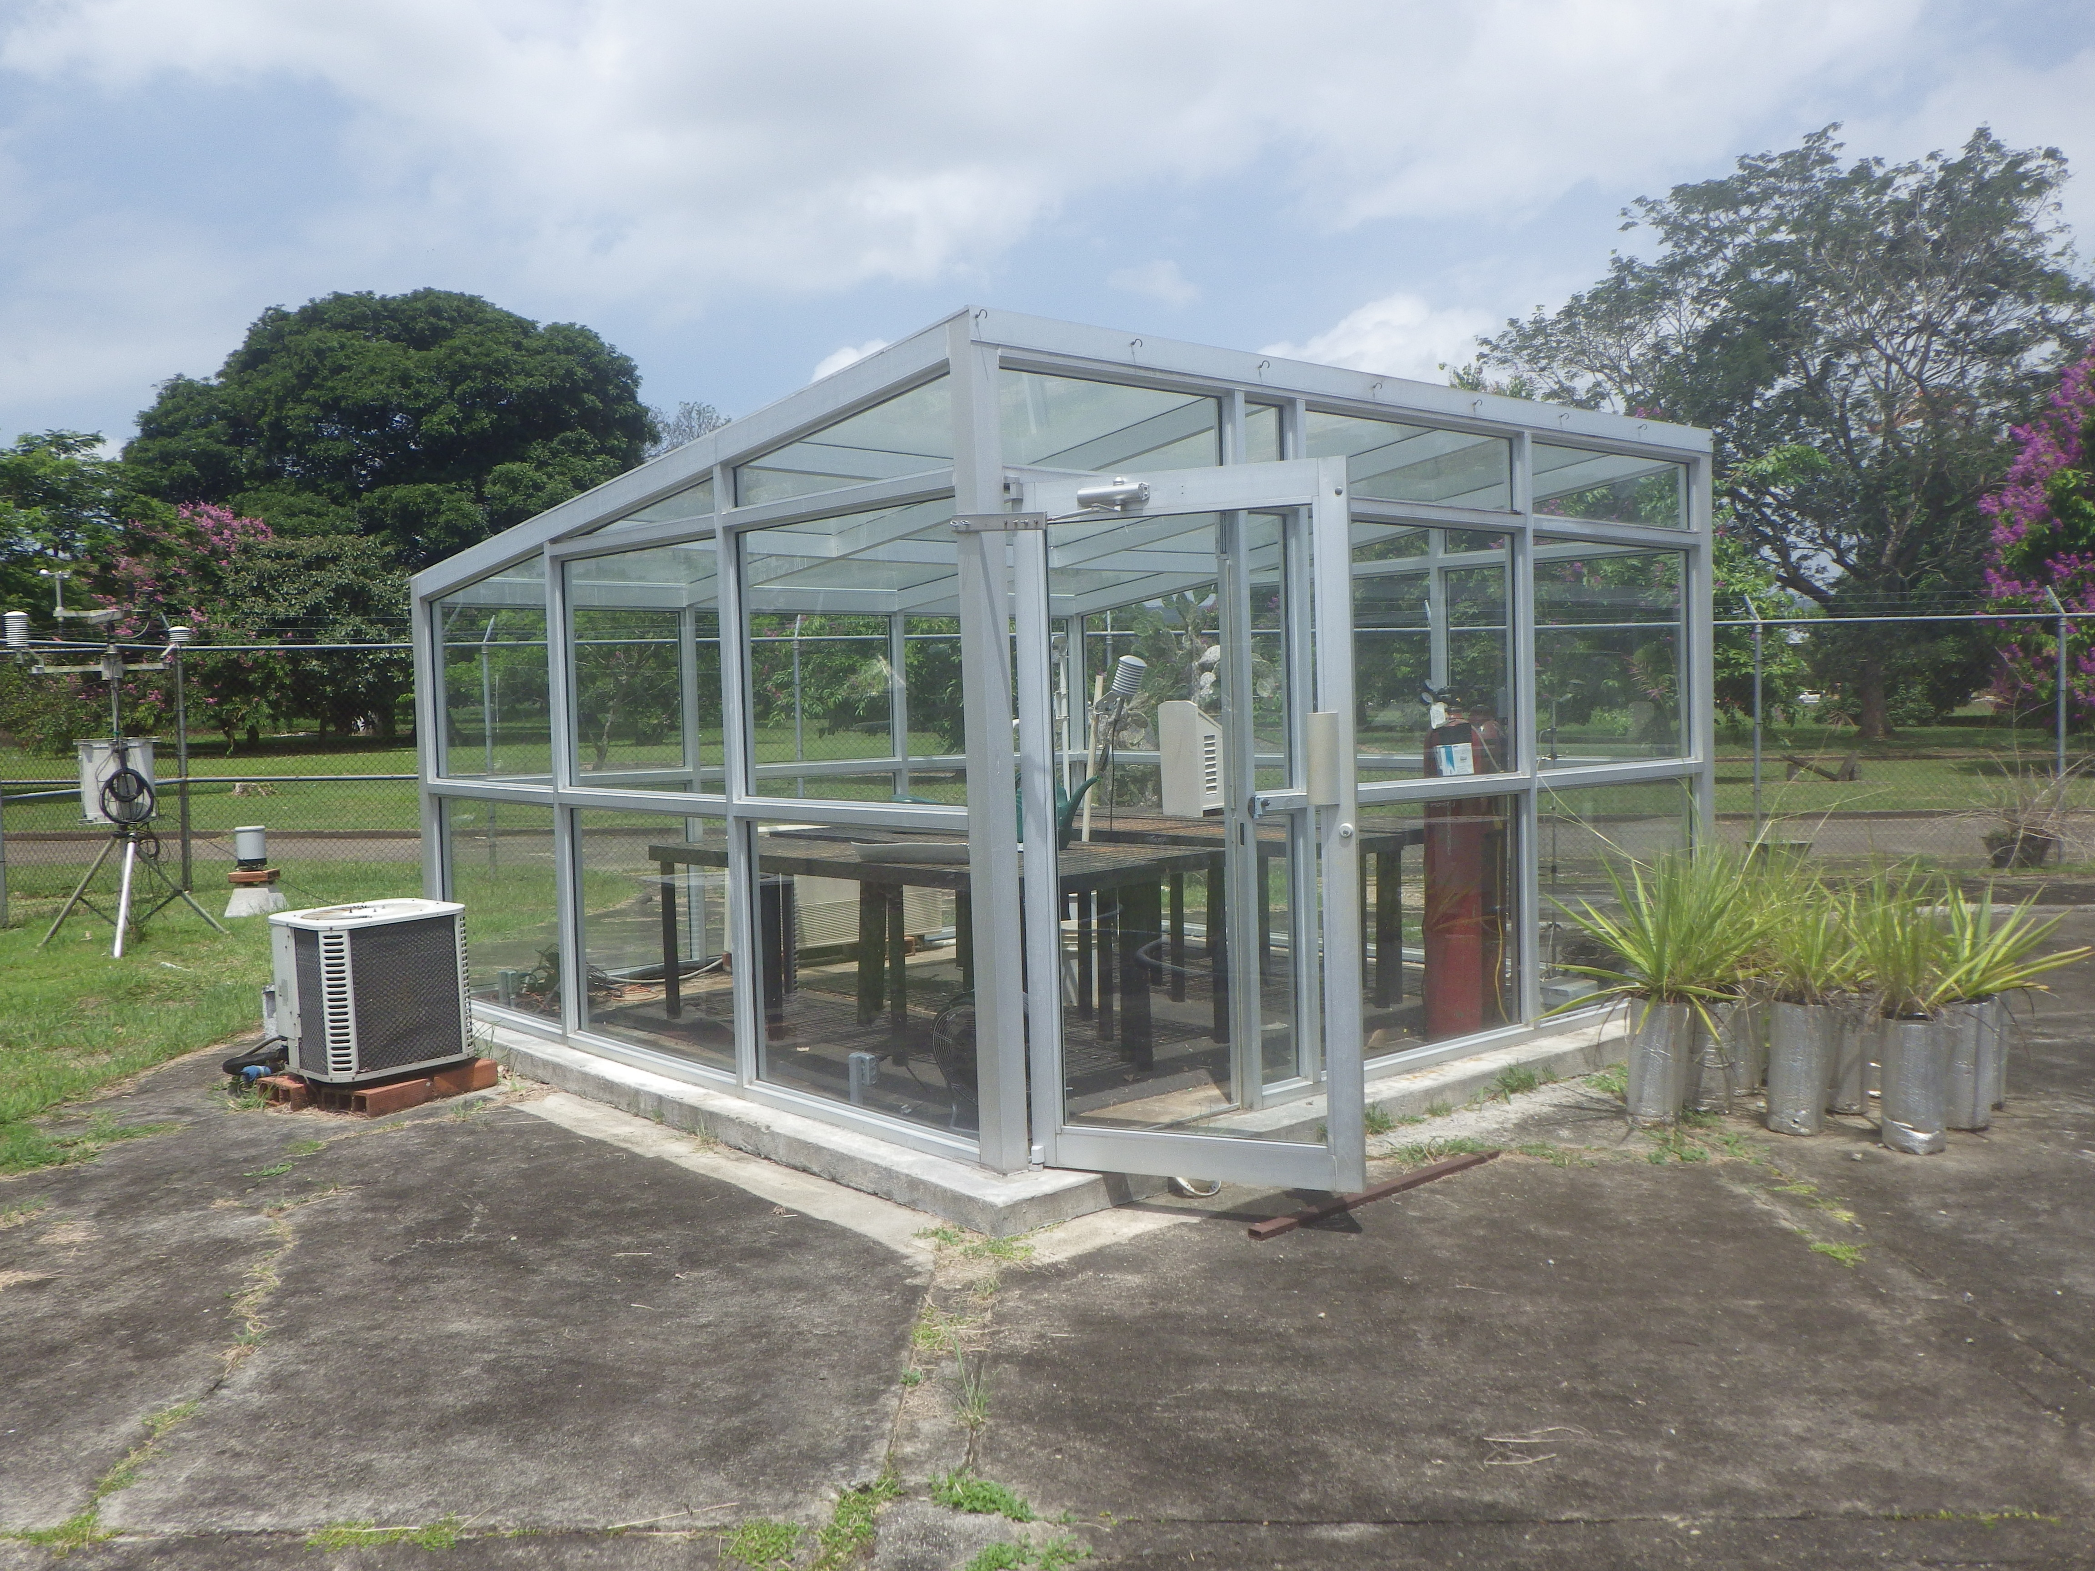
We experimentally manipulated [CO2] and temperature in growth chambers to quantify their effects on biomass, growth rate, foliar chemistry, larval performance and survival.

Fig. 2. Growth chamber with 2X CO2 treatment.

We discovered:
1. Whereas temperature had no effect, doubling CO₂ more than doubled plant biomass. Accordingly, leaves expanded faster in doubled CO₂ while temperature had no rate effect.
2. Univariate tests showed that [N] was principally influenced by leaf age, whereas [C] was affected by a CO2 and temperature interaction. Young leaves had a greater percentage of N than mature leaves. Leaves grown in warmer temperatures, but normal CO2, had the highest percentage of C.
3. Larvae in high temperature and double CO2 had disproportionately greater mortality.
4. Pupal mass was affected by a significant CO₂ X temperature interaction: those in high temperature and normal CO₂ were the lightest, whereas those in high temperatures and double CO2 averaged slightly heavier. Control pupae were the largest.
5. Larval development rates did not differ among treatments.
6. Number of days as pupae significantly increased with high temperature.
7. Pupal survivorship was affected by both the CO2 and temperature: the proportion of pupae that eclosed decreased for larvae reared at warmer temperatures but increased for those reared in double CO2.
8. CTmax of A. sparsa larvae was 45.2 °C.9.
9. We are in the process of quantifying changes in foliar concentrations of octadecanoic acid, phytol, and pheophorbide, which are essential precursors for larval defensive shields.
Overall, these results are consistent with predicted disruptions of multi-trophic trophic interactions associated with forecast changes in climate. Our findings indicate that these changes will be deeply consequential, chiefly due to a [CO2] x temperature interaction and will likely unfold in the tropical forbs like Merremia as increased plant biomass, shifts in C:N ratios, and reduce herbivory by those dietary specialists dependent on their hosts for defensive compounds.

